PYTHON

S.R.TAANUSRI

20.12.2023

**NUMPY**

1. NumPy is a numerical computing library in Python.

2. Core data structure: NumPy uses the `ndarray` for efficient array operations.

3. Broadcasting: Allows operations on arrays of different shapes.

4. Universal Functions (ufuncs): Provide element-wise operations on arrays.

5. Linear Algebra and Statistics: NumPy includes modules for these mathematical operations.

Arrays in NumPy

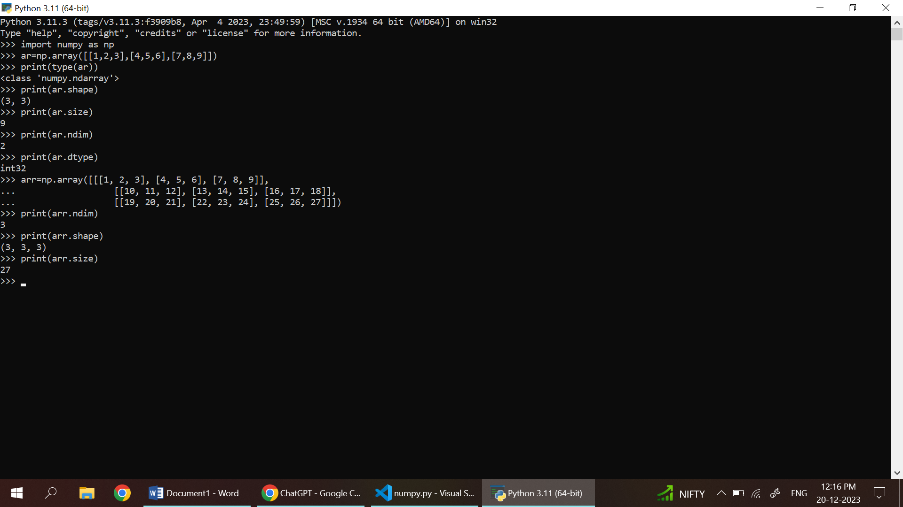

**NumPy Array Creation**

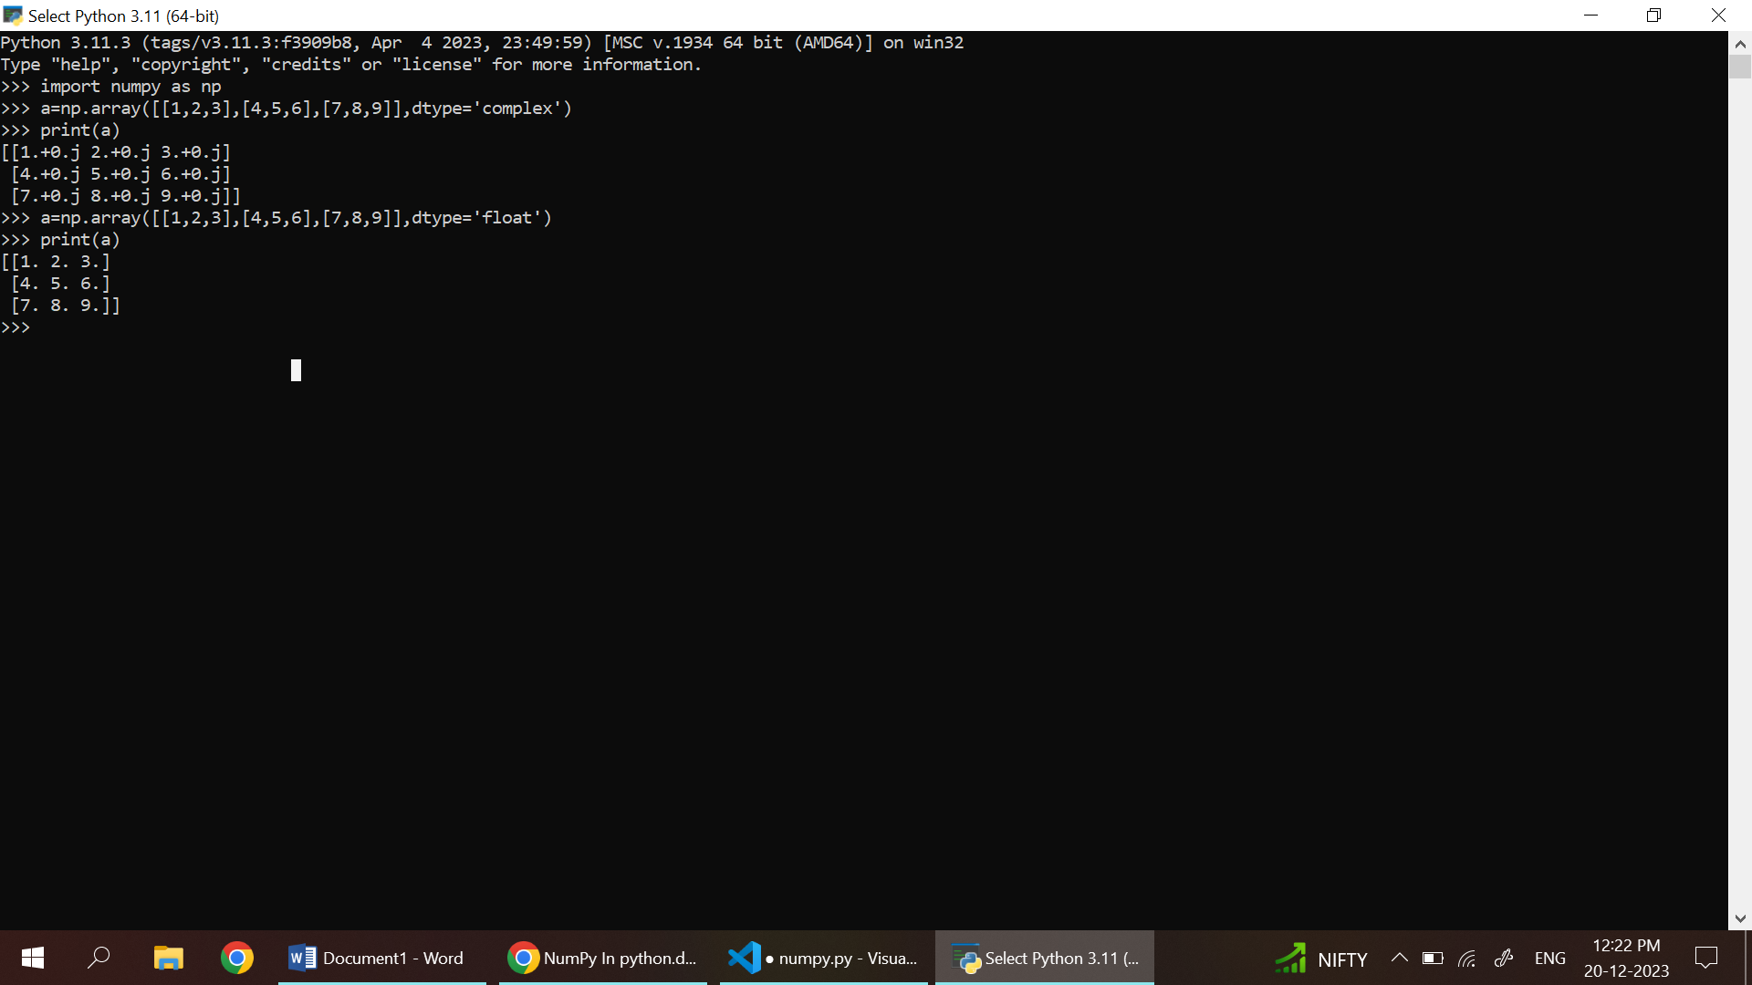

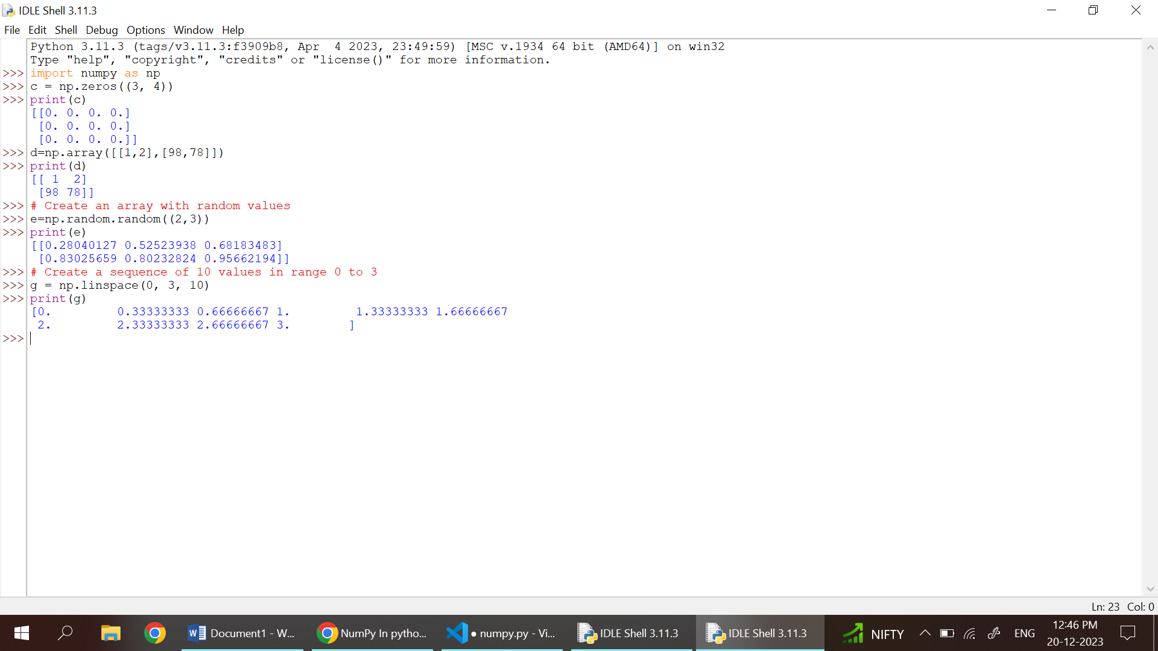

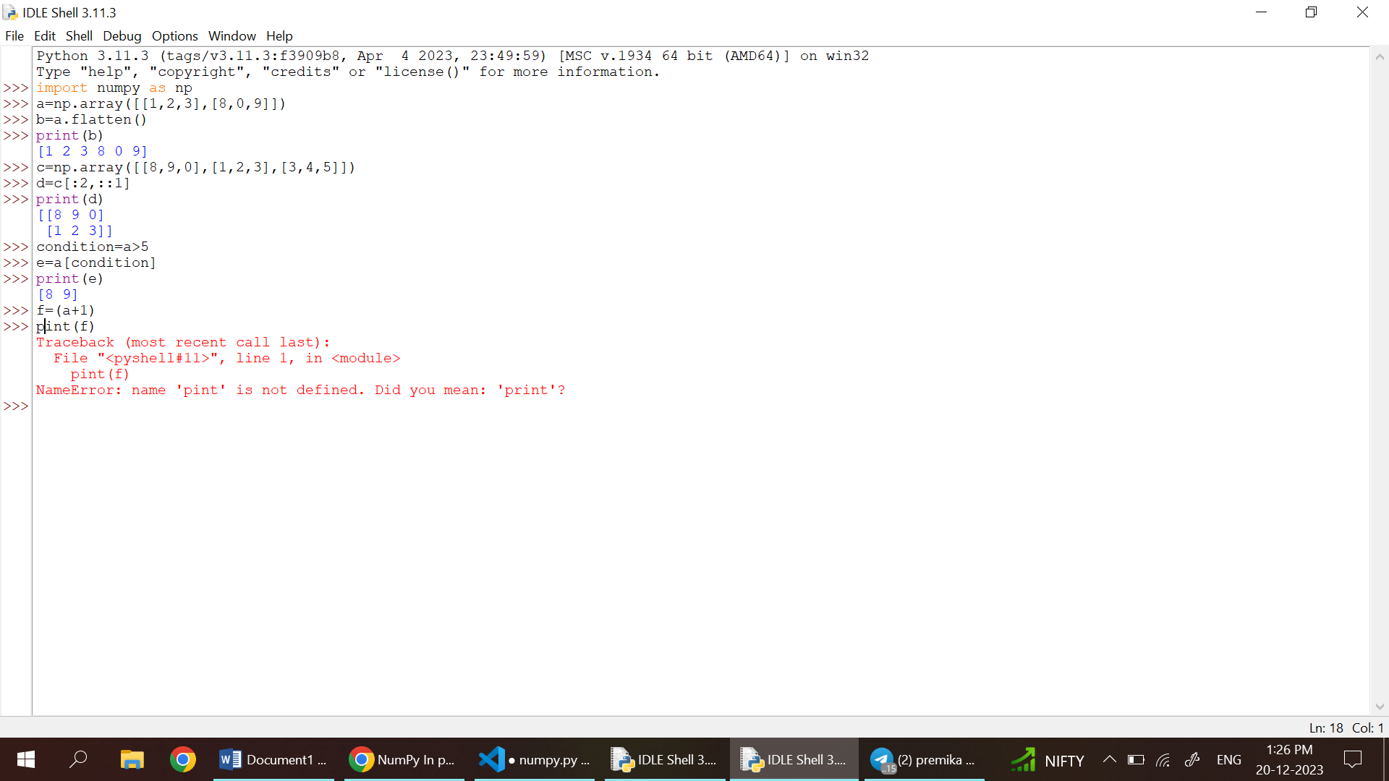

NumPy Basic Operations

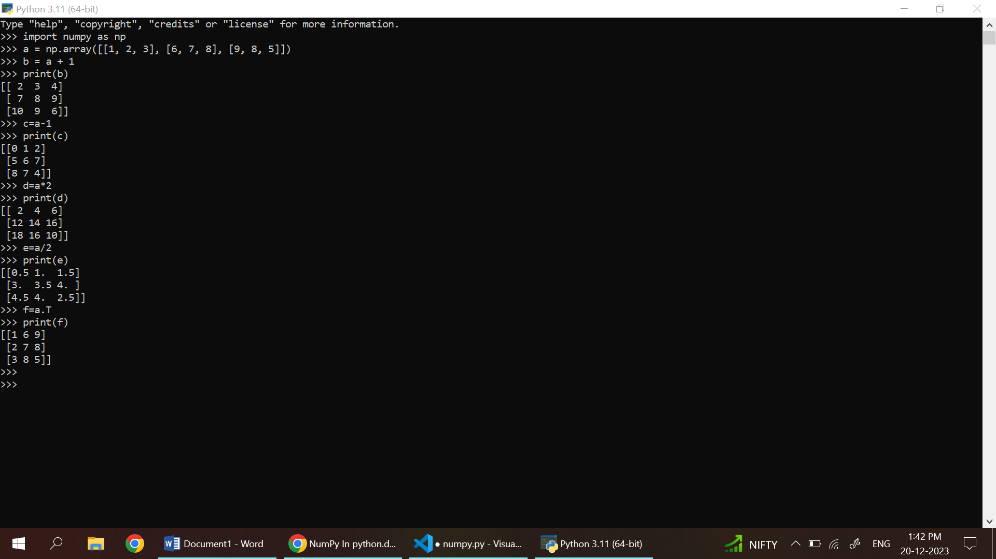

NumPy – Unary Operators

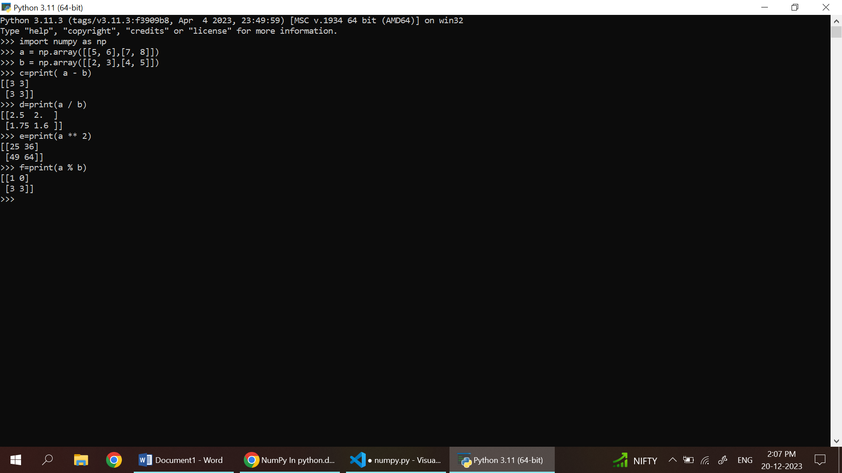

NumPy universal functions

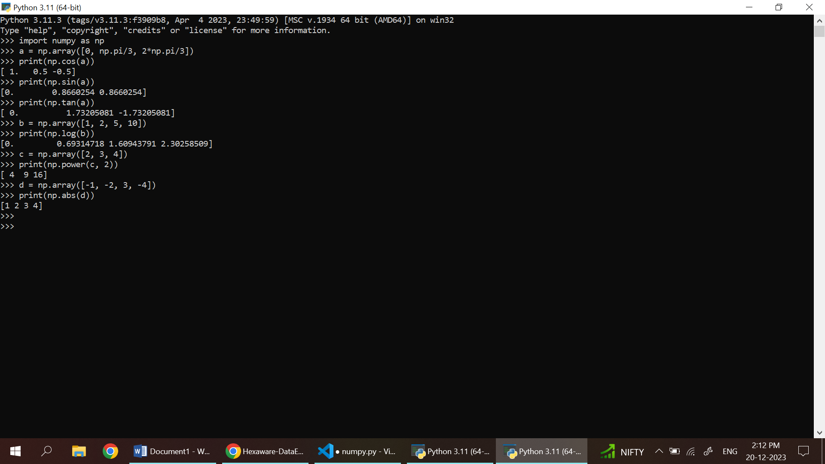

NumPy Sorting Arrays

